1. **C program to find reverse of a number**

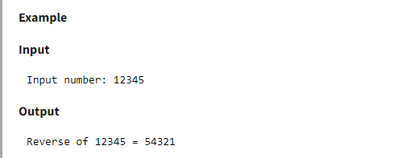

1. **C program to check whether a number is palindrome or not**

What is Palindrome number?

Palindrome number is such number which when reversed is equal to the original number. For example: 121, 12321, 1001 etc.

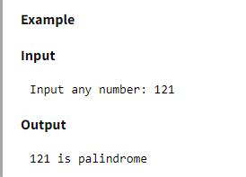

1. **C program to check whether a number is prime number or not**

What is Prime number?

Prime numbers are the positive integers greater than 1 that is only divisible by 1 and self. For example: 2, 3, 5, 7, 11 etc...

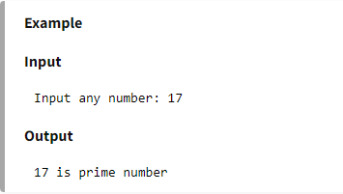

1. **C program to print all prime numbers between 1 to n**

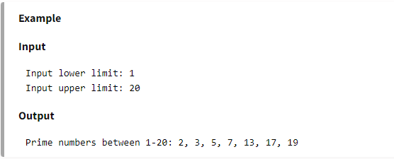

1. **C program to find sum of prime numbers between 1 to n**

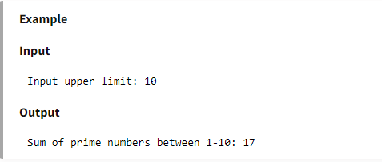

1. **C program to check whether a number is armstrong number or not**

What is Armstrong number?

An Armstrong number is a n-digit number that is equal to the sum of the nth power of its digits. For example -

6 = 61 = 6

371 = 33 + 73 + 13 = 371

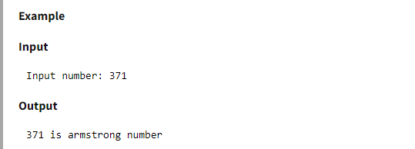

1. **C program to check whether a number is perfect number or not**

What is Perfect number?

Perfect number is a positive integer which is equal to the sum of its proper positive divisors.

For example: 6 is the first perfect number

Proper divisors of 6 are 1, 2, 3

Sum of its proper divisors = 1 + 2 + 3 = 6.

Hence 6 is a perfect number.

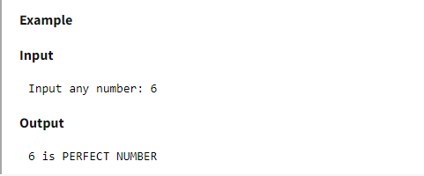

1. **C program to check whether a number is Strong number or not**

What is Strong number?

Strong number is a special number whose sum of factorial of digits is equal to the original number.

For example: 145 is strong number. Since, 1! + 4! + 5! = 145

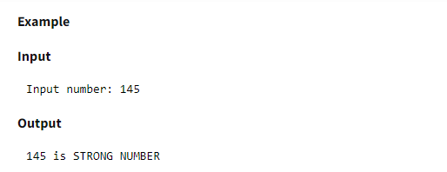

1. **C program to find all factors of a number**

What is factor of a number?

Factor of any number is a whole number which exactly divides the number into a whole number without leaving any remainder. For example: 2 is a factor of 6 because 2 divides 6 exactly leaving no remainder.

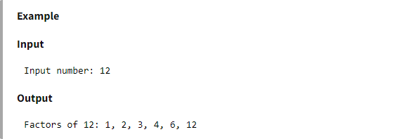

1. **C program to find factorial of a number**

What is factorial?

Factorial of a number n is product of all positive integers less than or equal to n. It is denoted as n!.

For example factorial of 5 = 1 * 2 * 3 * 4 * 5 = 120

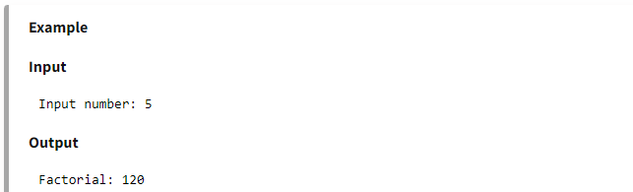

1. **C program to find HCF (GCD) of two numbers**

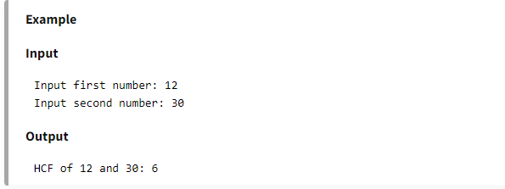

1. **C program to find LCM of two numbers**

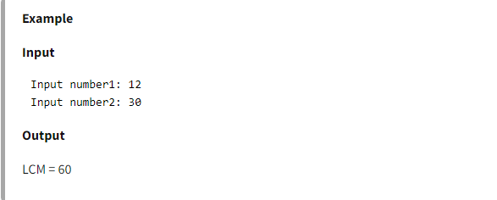

1. **C program to print fibonacci series upto n terms**

